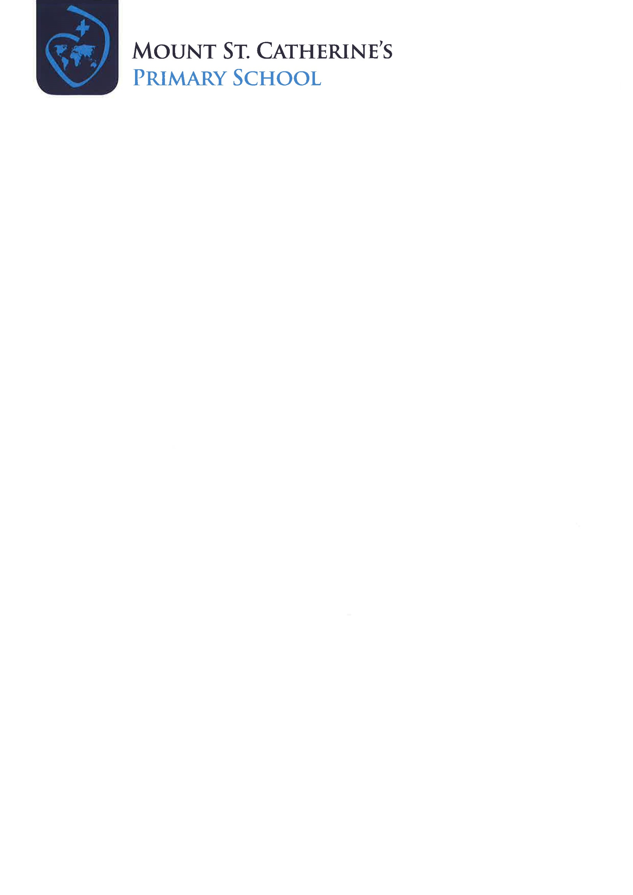

Principal: Mrs AM McLaughlin

Windmill Hill, Armagh BT60 4BR

Tel: (028) 3752 2241

Fax: (028) 3752 7422

Email: amclaughlin041@c2kni.net

Web: www.mountstcatherines.co.uk

Thursday, 5th October 2023

Dear Parents/Guardians,

As you are aware we are working hard to prepare your child for the Sacraments of Reconciliation and First Eucharist.

We would like to confirm that the date for **First Holy Communion** is Saturday 11th May at 2pm in St Patrick’s Cathedral.

The date for **First Penance** (The sacrament of Reconciliation) yet to be arranged but it usually takes place an evening during Lent.

**This Saturday 7th October** is the first **Do This in Memory Mass** at 6.30apm in the Cathedral.

These are Parish Masses where the priest especially focuses on the children in all the Parish schools who will receive sacraments this year. The children are asked to take part and it is to help them understand the mystery of the Mass better and allow them to meet other children also in P4. You and your family are so welcome and it is good for your child to be able to take part. The Cathedral is a big place and it is lovely if they have visited lots of times before they come for Penance and First Communion.

The children are asked to come forward, arms across their chest for a blessing when the rest of the congregation receive the Eucharist and it makes them really look forward to the day they too can actually fully take part.

Yours sincerely,

AM McLaughlin

Mrs AM McLaughlin

Acting Principal