Mount St. Catherine’s Primary School
Pastoral Care Policy

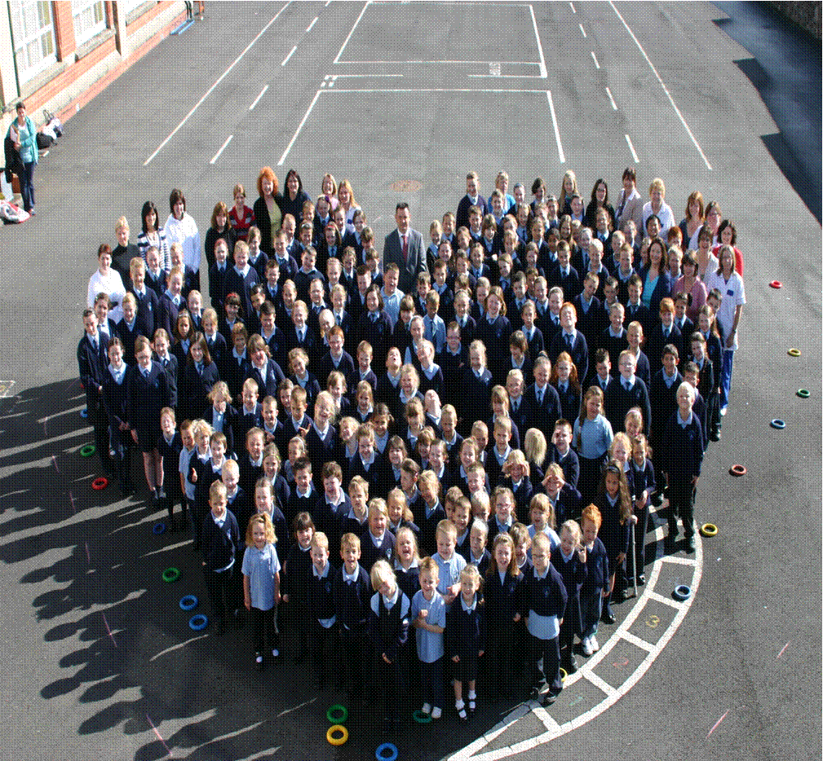

Last Reviewed _________________ due for Review ______________________

Signed , chair (BOG) ___________________________________

Introduction
Pastoral Care is an all-embracing term which describes the whole atmosphere, ethos and tone of our school in its, mission to promote the moral, intellectual, personal and social development of each pupil.
The introduction to Mount St. Catherine’s School Mission Statement well describes the nature of pastoral care in our school:
Mission Statement

Teachers, parents and governors will work together to develop each child spiritually, morally, intellectually, socially, emotionally and physically within our Sacred Heart ethos, so that by realising their potential, they can maximise it and have an appreciation of self-worth and self-learning.

“Welcome them with kindness and give them encouragement, so that their hearts will open out and you will be able to help them by advice to form their characters”
Saint Madeleine Sophie Barat
(Foundress of the Religious of the Sacred Heart)

The Network of the Sacred Heart Schools and Our Five Ethos Goals

Mount Saint Catherine’s is a proud member of the Network of Sacred Heart Schools and as such has a strong ethos informed by the charism and philosophy of the Religious of the Sacred Heart. We belong to an international network of schools with whom we share five underpinning goals of Ethos. These are:
- A Living Faith
- Personal Growth
- Intellectual Values
- Building Community
- Active Social Awareness
Every year the schools in the Network focus on one of these goals and develop an Ethos action plan that involves the whole school community. The outworking of these goals drive forward our Pastoral Care in every aspect of school life. They guide our behaviour and identify us as belonging to a common family. They are the public expression of what we are and what we stand for. In effect, they express our corporate identity. The active pursuit of these Goals will bring us safely into the future because the values they represent transcend time.

As a UNICEF Rights Respecting School our school Pastoral Care Policy is underpinned by the United Nations Convention of the Rights Of The Child and every one of the 54 articles. We point especially to the following two articles in all areas of Pastoral Care:

Article Three
The best interests of the child must be a top priority in all things that affect children.
And

Article Nineteen
Governments must do all they can to ensure that children are protected from all forms of violence, abuse, neglect and bad treatment by their parents or anyone else who looks after them.

Aims
Pastoral care in Mount St. Catherine’s encompasses and pervades the whole life and work of the school in which:

- all the pupils and all the staff feel valued as individuals, feel safe and secure and are encouraged to develop their gifts and talents.
- the staff work well together, as an effective team keeping the pupils’ interests and welfare as their main focus.
- there are good relationships between teachers and pupils and among pupils within and outside the classroom.
- the pupils are secure and are protected from emotional and physical harm.
- the pupils’ opinions are valued and their worries and concerns are dealt with sympathetically and appropriately.
- the self-esteem of the pupils is promoted and they have opportunities to develop independence of thought and expression.
- the pupils are taught to work with their peers and to value and respect the opinions of others.
- our parents/guardians are closely involved in and knowledgeable about the life and work of the school.

- the school has clear lines of communication and good, flexible relationships with relevant external advice and support agencies, e.g. Council for Catholic Maintained Schools (CCMS) The Education Authority (EA), The Department of Education for Northern Ireland ( DENI), School Medical services, social services, police, etc.
- the school, through the implementation of its Behaviour and Discipline Policy, works to promote and sustain good and high standards of behaviour and discipline which reflect an appropriate balance between rewards and sanctions. Disciplinary procedures are implemented consistently by all staff in a fair and positive manner, where required.

Responsibility
While the Board of Governors, Principal and senior management have primary responsibility for the arrangements that promote and ensure the care and welfare of pupils and staff, it is obvious that pastoral care in the school is also a shared responsibility, involving the whole staff in co-operation with parents and pupils and others. This operates well through the teams in school.
All members of staff have the support of the Principal in matters of pastoral care and also have access to external support agencies including the Pupil Personal Development Service.

The Pastoral and Ethos Team
Mount St. Catherine’s Pastoral Care Coordinator is Mrs Anne- Marie McLaughlin. The Pastoral Team is comprised of:

- Mrs McLaughlin, the Principal
- Mr Peter Gildea
- Lay Chaplain, Mr Matthew McFadden
- Sacred Heart Co-ordinator, Mrs Brogan
- Sister Nora Smyth rscj (Religious of the Sacred Heart of Jesus),
- Cathy Mc Ardle (Classroom Assistant)
- Aileen Matthews, Board of Governors
- Representative parents
- Ten pupil representatives
Members of the team meet half-termly to discuss matters of ethos and pastoral care in school. This may involve community events, fundraising, playground issues, religious celebrations and Parish involvement.

The School Safeguarding Team

The school Safeguarding Team takes particular responsibility for the Pastoral care, Safeguarding/Child Protection, Health, Safety and Well- being of the pupils and the school community. The team consists of :

- Mr Peter Gildea (principal)
- Mrs Anne Marie Mclaughlin (vice principal and Designated teacher for child protection)
- Mrs Cathy McKenna (Special Educational Needs co-ordinator and Deputy Designated Teacher)
- Mr Eoin Mc Guigan (Using ICT co-ordinator)
- Sister Nora Smyth (rscj and Board of Governors)

The Safeguarding Team meet monthly and a report is prepared for every Board of Governors’ meeting by Mrs McLaughlin. Matters of policy and procedure are discussed and the Child Protection Register reviewed

Child Centred Provision

As A UNICEF Rights Respecting School, involved in the Rights Respecting School Project we promote the rights and responsibilities of pupils in all areas of school life and where possible the community, using pupil committees and other democratic means.

Rights of Pupils:
- to be treated fairly
- to be listened to
- to be respected
- to learn to your full potential
- to feel safe and secure
Responsibilities of Pupils:
- to treat everyone with respect
- to listen to others
- to show respect to everyone
- to ensure everyone has an opportunity to reach their potential
- to keep yourself and others safe

Safeguarding

There is a Child Protection Policy and Guidelines Document relating specifically to matters of Child Protection and Safeguarding. At Mt. St. Catherine’s we believe every child has the right to be safe. As such all staff and volunteers are trained annually in safeguarding matters.

All staff and volunteers working in school are vetted with an Access NI check before commencing work with children.

There is a Safeguarding and Child Protection Policy and Procedures document made available to all staff and families that outlines procedures in a simple flow- chart should any member of the school community be concerned for the safety or health and well-being of a pupil or staff member.

(Translated versions are given to families whose first language is not English.)

Pupils are kept informed about the safeguarding team, procedures and how to protect themselves through pastoral assemblies, class circle time and the PD & MU curriculum. There are “Keeping Safe” noticeboards for pupils, suggestion boxes in classes as well as activities during Anti-Bullying Week and Internet Safety trainings.

This component of pastoral care refers to school’ s policies and procedures that aim to protect the children from physical and emotional harm, from neglect and from any form of abuse. In our school the well -being of the child is paramount over any other interest. It also deals with the need for the school to ensure that the curriculum includes a programme for pupils on self-protection. There is a designated teacher in charge of child protection; Mrs AnneMarie Mclaughlin and a deputy designated teacher Mrs Cathy McKenna. Sr. Nora Smyth is the school governor who has special responsibility for this area.

Additional Learning Needs

We seek to address the additional learning, social, medical, emotional and behavioural needs of all members of the school community in order to overcome and prevent barriers:

- By promoting good attendance.
- By promoting positive behaviour
- By being a welcoming school
- By following SEN (Special Educational Needs) policy in regard to provision and being inclusive
- By seeing each child as an individual
- Encouraging a happy and positive attitude
- By developing good links with parents
- By assessing attitudes to school and self, using GL assessment PASS survey

SENDO
Every child is treated as an individual here at Mt St Catherine’s and every child’s needs paramount. The teacher with overall responsibility for this area is Mrs Cathy McKenna. To ensure the appropriate response to all of our children’s needs and to comply with SENDO (Special Educational Needs and Disability Order) it is important that all members of staff are informed of a child’s specific learning or possible medical conditions e.g. Autism, Hyperactivity, diabetes, allergies etc.
All members of staff have received training on Risk Assessment (Awareness Raising) and De-escalation and Diffusion of Challenging Behaviours.
Our school has rigorous policies and procedures in regard to the additional learning, social, emotional and medical needs of pupils. ( See Special Educational Needs Policy)

A Health-Promoting School

We support children in making healthy life choices and ensure a safe and secure environment where healthy activity is available: We ensure:
- Appropriate First Aid trained staff and equipment, including a defibulator
- Rigorous Health and Safety audits and procedures
- Safe drinking water for pupils
- Healthy food choices are promoted at breakfast club, break and lunchtime Eg : Healthy Eater Awards
- A broad, properly equipped PE curriculum
- Suitable play facilities and equipment at playtime
- A wide Extended Schools Programme of activities
- Involvement in community programmes for health and well being

Relationships

This feature of pastoral care refers to the harmonious relations which are striven for nurtured and developed in the school between staff and pupils and among the pupils within and outside the classroom. This is guided by our ethos of mutual Christian respect and staff follow the Code of conduct for staff policy.
It also encompasses mutual respect, tolerance, the approachability of staff, the growth of pupils, and the expectations that each bring to the school situation.
Pupils have a sense of security and are free from emotional and physical harm. Teachers are fair, consistent and compassionate in their approaches to discipline.
All of the staff at Mount St Catherine’s are expected to embrace this approach and thereby reinforce its practice throughout a pupil’s life in school.
Pupils have a voice, as individuals and are represented by the School council. This is the student body, democratically elected by peers in classes P4 to P7. The School council should be representative of all groups in the pupil body- gender, faith, ethnic and nationality wherever possible. They have a recognised role to play, seeking ways to improve the school for everyone and informing the way in which the school and its policies are developed, implemented and evaluated. For example, the School Council help with surveys, questionnaires, public events and celebrations during the school year.

Pupils are encouraged to develop positive relationships at all times, in all formal and informal situations, especially using the Personal Development and Mutual Understanding (PD & MU) curriculum

Each class devises a Class Charter of Conduct in a democratic, collaborative way.
The pupil Ethos committee members form a playtime friendship squad, developing play and co-operation in the playground.

Circle Time and Pastoral assemblies educate pupils about positive relationships.

Peer Mediation- the school operates conflict resolution, training Peer Mediators who help pupils independently solve disputes wherever possible

Teachers and other staff interactions with pupils and colleagues are required to be positive and respectful, following the guidelines laid out in the Staff Code of Conduct.

Staff are encouraged to be reflective practitioners who ensure their own continuous professional development in order to ensure the best outcome for the pupils in their care.
School Leadership.

School Governors and senior leaders understand their role in being responsible for the overall pastoral care of pupils and staff. They do this by:

- Monitoring and evaluating strategies and programmes involving pastoral care, for example by reviewing the School Development Plan, examining policies and seeking reports from co-ordinators.
- Ensuring involvement from all stakeholders in pastoral matters
- Ensuring appropriate training takes place for governors, managers and staff in safeguarding matters
- Monitoring the reporting of Behaviour, suspension and exclusion.
- Ensuring professional development of staff and sharing of good practice
- Ensuring the appropriate resources are available for Pastoral Care in school to be a success
The Welfare, Health and Well-Being of Staff
The management of Mount St Catherine’s recognises that care of staff is vital to ensure that stress and low morale do not jeopardise the success and prosperity of school life.
In schools, high pupil morale and expectations are difficult to establish and sustain without high teacher morale and expectations. School staff are valued highly and great care by management to show empathy and understanding to all staff in all matters pertaining to the life of the school and also home.
At school level the promotion and development of staff welfare and development is a responsibility of the Board of Governors, Principal and senior management but it is also the mutual responsibility of all colleagues in school. Staff health and well-being form part of the annual school development plan.
It is also recognised that some of the sources of stress and low morale in schools (as in other organisations) often lie outside the influence of the schools themselves.

The Board of Governors’ and management need to be alert to the holistic needs of staff under their care and strive to support measures that will promote overall health and well-being .

The principal undertakes personal interviews with all staff members in September and there is both a professional and a pastoral aspect to these.
Opportunities are provided for staff to reflect on well-being via organised seminars throughout the year.
Staff occasions and achievements are celebrated in community.
Staff are made aware of counselling services available to them.
Informal social occasions are encouraged and organised on a regular basis.

The Learning and Teaching Environment

This aspect of pastoral care refers to the action of staff, management and premises manager and her team in ensuring safe, clean, comfortable and pleasant environment throughout the school for learning and for leisure. We are delighted that the very highest standards are met in this area and constantly strive to improve the physical environment for our pupils and staff. The condition of the school building in general is first rate and we have access to excellent outdoor facilities both in our own grounds and those of St. Catherine’s College. We have two new outdoor learning environments which will greatly enhance the learning experience for the pupils as well as a newly equipped ICT suite.

All staff strive to create and maintain a welcoming and positive classroom climate: A quiet, calm relaxed attitude combined with fairness and a sense of purpose. Pupils are encouraged to take ownership of their learning spaces and help both maintain and enhance them. Staff demonstrate an interest in and knowledge of the pupils individually and mutual respect, the pupil recognising the personal qualities, knowledge and skills of the teachers and the teachers being sensitive to the needs of the pupils and respecting their contributions. An atmosphere of positive motivation underlies all learning and teaching.

Partnership and Consultation with Parents

This aspect of pastoral care refers to the school’ s arrangements for keeping parents informed and up-to-date about their children’s progress and about developments in school. We constantly strive to have better and more informed communication with our families.
For example:
- We have annual face to face meetings with parents and guardians in October and present a written report in June.
- Parents receive regular communication via the school website, texts, the school app and regular newsletters.
- There is a Parent Noticeboard in the playground and also at the reception.
- There is a vibrant School Support Group, mainly comprised of parents who act as a vox pop for various points of discussion. They also organise community events and help fundraise for the school.
- Parents are represented on the Board of Governors and the School Ethos Team.
- We are funding a Parent liaison post at the moment with Extended Schools funding and the feedback on this from staff and parents is very positive. An important part of this role is organising translation for families whose first language is not English and making direct person-to-person contact when there is an issue regarding a pupil.
- We employ bi-lingual staff where possible to better enable communication and inter-cultural understanding.
- We have a Family Room where informal and information meetings can take place and on a regular basis offer parents seminars and meetings to help families to better support their child in school.

Extra-Curricular Activities

This feature of pastoral care refers to the opportunities the school provides for learning and social activity outside the formal classroom setting. With Extended Schools funding we are able to offer a wide range of after school activities and support for pupils in our school. Pupils are encouraged to make suggestions for after school activities which we try to facilitate where possible. The one hour Homework Club for Key stage one 2-3pm and KS2 -3-4pm is an extremely important intervention and the pupils for this activity are suggested by teaching staff as being in need of this support. We also have a Breakfast Club and Out of School facility (Big Buds) that is open until 5.00pm during term-time. The Big Buds operates as a Community Organisation, independent of the school and is overseen by social services. The Extended Schools activities are planned, co-ordinated and evaluated by Mrs Brogan and Mrs Trainor. All facilitators and coaches are vetted.

Combatting Bullying

Bullying is the wilful, conscious desire to hurt or threaten or frighten someone else through physical, verbal, emotional or psychological aggression. Children are taught that any form of bullying is unacceptable and that such behaviour will be dealt with appropriately by the staff of the school.
Individual members of staff are alert both inside and outside the classroom. Children must be aware that it is the responsibility of everyone to report acts of bullying as soon as they arise. They need to be aware that this is not ‘telling tales’. To be seen to act is as important as taking action. Silence and secrecy nurture bullying. We give the children the strong message that we are a “Telling School”. The school has an Anti- Bullying Policy, which is given to all new parents and adults who work with the children.

Strategies/Resources used to promote the Pastoral Care of our children include:  Extensive Personal Development and Mutual Understanding Curriculum.  Circle Time | Each Class plans PD & MU activities appropriate to their age group on a two- monthly planner  Circle time allows children to participate as partners in the process of developing responsibility for their own behaviour and learning.  A regular time is set-aside for Circle Time in class. It may also take place between set times as the need arises or as a cross-curricular teaching and learning tool. This forms an integral part of our discipline policy and pastoral support for the children.

Kidscape Resources and NSPCC Stay Safe Programme  The School Council  Ethos Team  Peer Mediators | The material encourages awareness of the dangers of keeping some secrets and the importance of finding safe adults to tell.  The School Council, Ethos Team and Peer Mediators are made up of pupils elected from classes P4 to P7 and they assist in whole school projects and pastoral matters.
Award Assemblies | Golden Book and Pupil of the Week, Class Lining Up Awards and Principal’s Praise Postcards and Headteacher Certificates. Positive reinforcement
Class Assemblies  Unicef Rights Respecting School Programme  The above aspects of pastoral care are developed in a wide range of curricular policies. This overarching policy should therefore be read in conjunction with the following policies:  Anti- Bullying Policy  Positive Behaviour and Discipline Policy  Child Protection /Safeguarding Policy  Special Education Needs  Drugs and Medication Policy  Staff Code of Conduct  E- Safety Policy  Risk Assessment Policy  Absconding Policy  Health, Safety and Welfare Policy  Healthy School Policy  Whistleblowing Policy  Inclusion and Diversity Policy  RSE Policy  Attendance Policy  Intimate Care Policy  Data Protection Policy  Personal Development & Mutual Understanding Policy | Each year group prepares an assembly each year of their work or topic. This is performed/presented to the school and parents.  Our school has a yearly action plan working towards this school Award . We strive to have high levels of pupil involvement in all matters and the pupils learn about the Charter of Children’s Rights

