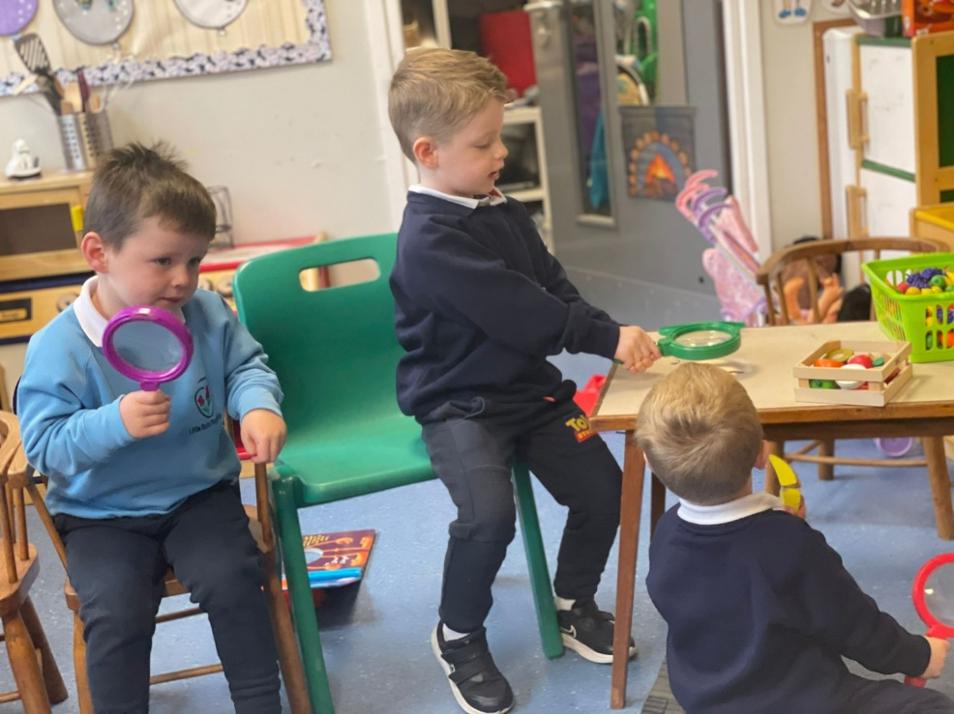

Little Buds

Playgroup

Investigating the playgroup

# Good to be back

Playgroup

# Look what inside:

Parent meets 2

Workshops 2

Fancy Dress 2

Space in Buds 2

Help with payments 3

Sickness 3

Keyworkers 3

Being safe 3

What we have been doing! 4

Autumn 2020 Newsletter



Little Buds

Mount St Catherine’s Little Buds

C/o Mount St Catherine’s P.S

Windmill Hill

Armagh

BT60 4BR

[littlebudspg@gmail.com](mailto:littlebudspg@gmail.com)

Mount St Catherine’s Little Buds

C/o Mount St Catherine’s P.S

Windmill Hill

Armagh

BT60 4BR

[littlebudspg@gmail.com](mailto:littlebudspg@gmail.com)

Our Dress Sponsored Walk

**Checking out the linking elephants**

We are looking forward to Santa joining us this year to deliver the presents as due to Covid, he has only been able to leave them under the tree and run.



Halloween is fast approaching, and we are looking forward to our Fancy Dress Sponsored walk. This is a fun way to raise some much-needed money for our playgroup. We ask that you remember that some costumes can be very scary and just to be mindful when choosing a costume for your child. We will be completing lots of Halloween crafts for you child to bring home to help decorate your homes.

So, after Halloween comes the best time of year! Christmas!!

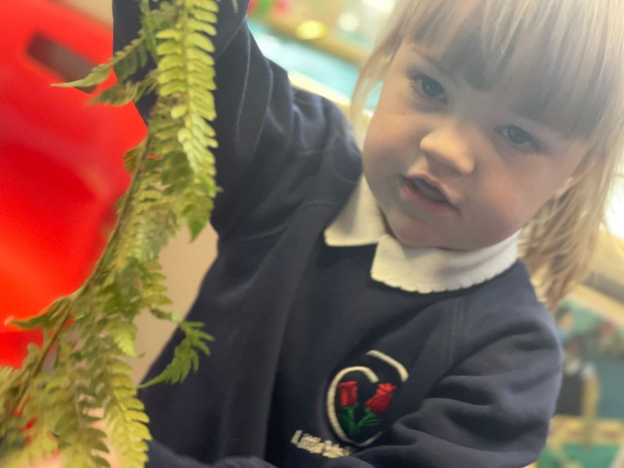

**Exploring Nature**

Welcome all!

We would like to welcome everyone to Little Buds Playgroup. It’s so lovely to see so many new faces, but also just as nice to see some children return. We hope you have as much fun as us!

Parent Workshops

We will be holding parent workshops in Eager and Able to Learn and Media Initiative soon. We will let you know the dates when we get organized. We will also be holding some stay and play days!! Details later!

[](https://www.bing.com/images/search?q=halloween&view=detailv2&qft=+filterui:photo-clipart&id=1433E803A03F2004CF6C61C21DD5B64EAF9903D7&selectedIndex=33&ccid=EWBMQwZs&simid=608027431733169996&thid=OIP.M11604c43066c2d404ed18ad1a478225co0)

Fancy Dress Walk

We will be holding our sponsored fancy dress walk on Friday 28th October. We hope this will raise money for new graduation gowns. We will also be having our Halloween party after the walk.

Spaces in Little Buds

Children can attend Little Buds from the age of 2 years 10 months. We still have one place left, so if you would like to increase your child’s days.

Waiting List

We have now a waiting list opened for children to attend the playgroup. Children can go on the list no matter what age. Please let us know if you would like any younger siblings on the list as if they are not, there might not be room for them when they are the age to attend.

Parent Meetings

We will be holding parent meetings after Halloween. This are short meetings to keep you up to date with your child’s progression and how they have settled into playgroup life. If you have any concerns or questions about your child, please feel free to talk to a member of staff at any time.

# Remember!

What to do when your child starts playgroup

1. Bring a change of clothes

Your child will be playing with water and will get wet from time to time. They also get nervous and may have a toileting accident.t

2. Pay fees on the first day

Fees must be paid on the first day that the child attends playgroup unless organized otherwise with the leader.

3. Come in time

Children should be in playgroup for 9am and must be collected between 12.15-12.30pm. Children can get distressed if they are the only ones left.

4. Appropriate clothing

Children should come to playgroup in clothes that they find easy to use. Tracksuit bottoms are ideal as they are easy to pull up and down when going to the toilet. Children should also bring coats and hats during colder weather.

5. Get to know the staff

Each child has a key worker, who should be introduced to you when you visit. Feel free to speak to her if you have any worries. The leader is also available at all times.

6. Talk about their day

Some children may not talk about playgroup or their friends for a while. Don’t worry, this is normal and when they get settled and become familiar with everyone, they might start talking then.

Facebook

We have a Facebook Page for Little Buds. This will have bits of information and will have some pictures of children’s work on it. It gives parents a chance to talk about what they have done in playgroup with their child.

Help with playgroup payments

If you work you might be entitled to some help with payments. You can register through your company for Tax Free Childcare. The government will pay £2 for every £8 you spend. You may also be able to claim for childcare through your Universal Credits.

Coats and Hats

It’s now the time of year for coats and hats. We love to get outside in Little Buds to allow the children to get fresh air and good physical play, so please send a coat and hat with your child each day. Please also remember to send in a pair of wellie boots for your child as we do love to wear them with our puddle suits.



Keyworkers

Children will have been allocated a keyworker. Please check the list at the back to see who you child’s keyworker is. Keyworkers observe your child and ensure that they are being challenged in their learning.

Road Safety

Parents must now park on the hill outside the school. We understand that the traffic can be a bit crazy due to school and playgroup traffic. We ask that you **do not park at the gate at any time.**  This is a huge road safety concern.

Sickness

Please do not send your child into playgroup if they are not well. This is unfair to your child and to the staff as we all have someone who is vulnerable at home. The playgroup follows the PHA guidance for infectious diseases and we have included it in this newsletter.

Early Bird Club

Little Buds now have an Early Bird Club which means the playgroup opens at 8.30am for parents who need to be at work that wee bit earlier. This costs just £1 per day. Please let us know if you need your child to start a wee bit earlier. When coming to the club, please make sure the gate is close tight on your way in and also on you way out of the playground.

| Upcoming Holidays | Events |
| --- | --- |
| Halloween  Monday 31st October- Friday 4th November  Christmas  Wednesday 21st Dec- Wednesday 4th January 2023 | Parent workshops  Media Initative  Eager and Able to Learn  (to be announced)  Christmas concert  To be confirmed |

If your child has had vomiting or diarrhea they need to remain at home for 48 after last episode.

**Funded places.**

As I’m sure you are aware the playgroup has yet to have any funded places. We are continuously applying for these places in hope that our preschool children will get the funded place that they are entitled to.

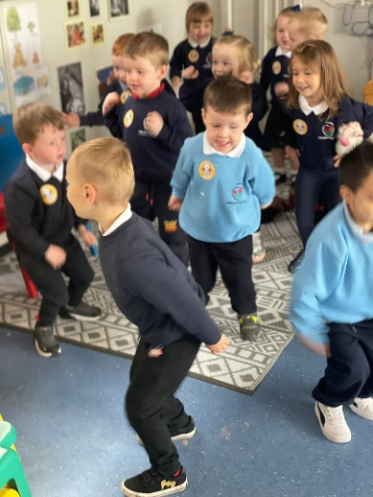

**Ha, Ha this away!**

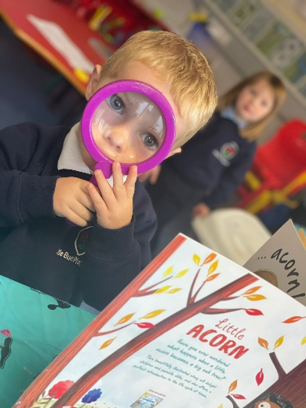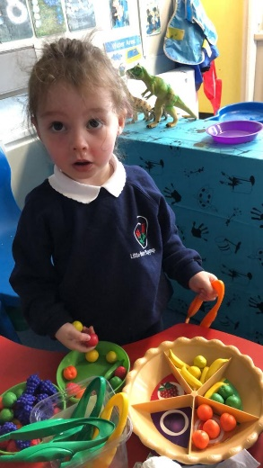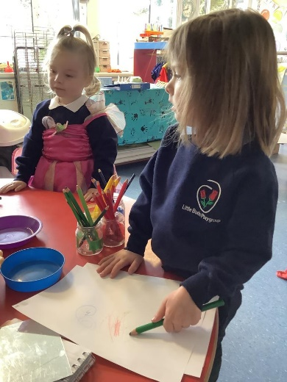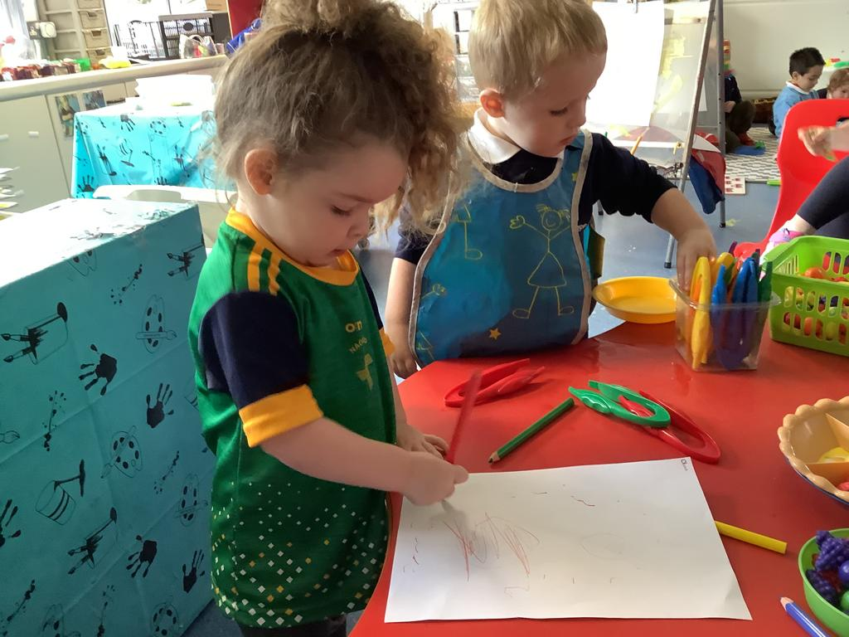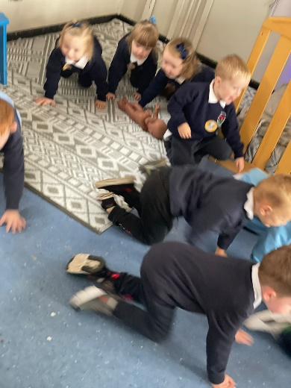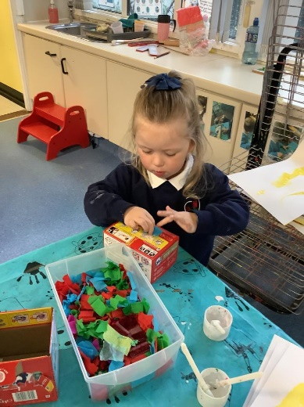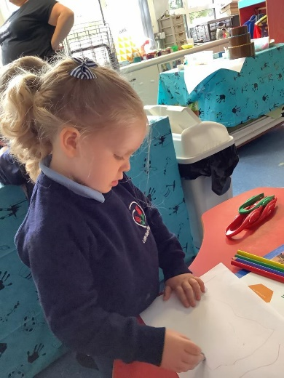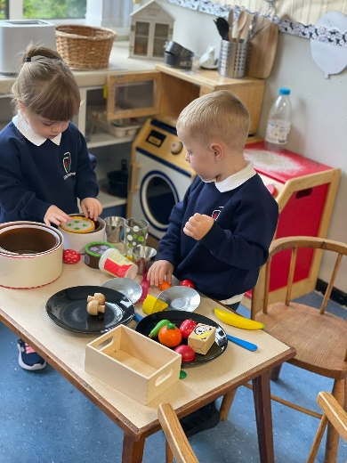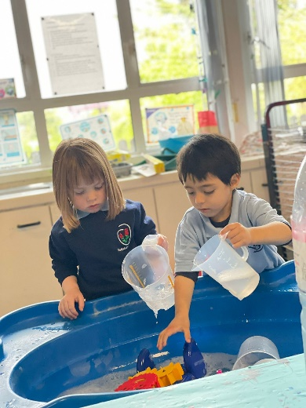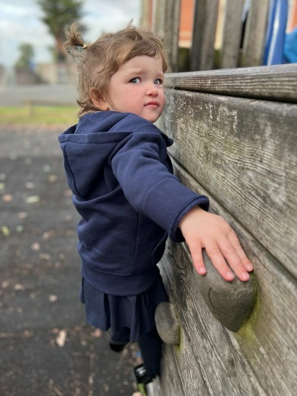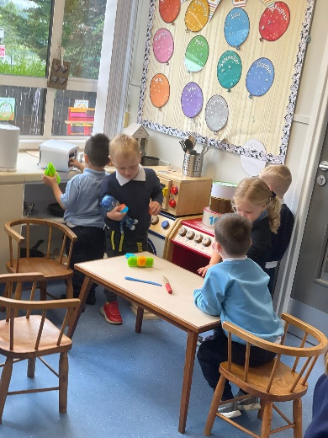

Look what we have been doing!